
Call for Late Breaker Abstract Submission

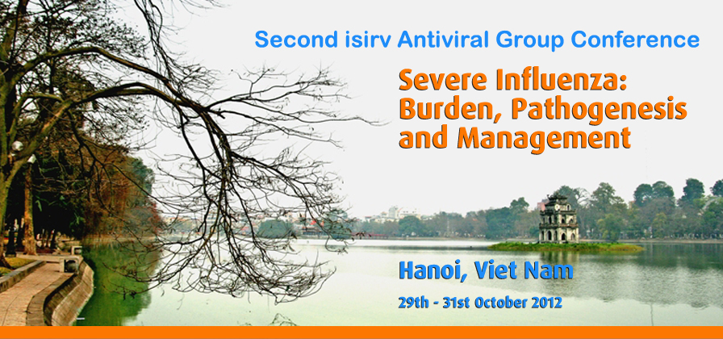

The organisers invite Late Breaker abstracts for poster presentations in the following areas:

- Severe influenza and SARI epidemiology
- SARI pathogenesis - viral and host factors
- Influenza in risk populations (eg pregnancy, immunocompromised hosts)
- Clinical management
- Influenza antivirals – effectiveness; safety; national policies; novel agents
- Antiviral resistance and its consequences
- Diagnostics – assays, algorithms, prognostic tools
- Adjunctive SARI therapies and critical care strategies
- Antivirals and therapeutics for other respiratory viral infections

The Deadline for submission of Late Breakers is Friday 28th September 2012.

Abstract format:

- The abstract in English is required to be in Microsoft Word (.doc). If you are using Word 2007 or later, please save as a Word 97-2003 document.

- The abstract should include the objectives of the study, methods used, the results obtained and conclusions.

- The entire Abstract, including title, author(s) and affiliation(s) must be no more than 400 words and typed single space in Arial 11 point font on a single page with 1½ inch margins, top and bottom.

Abstract

Title: (must be in ‘bold’ with a capital letter for each new word)

Author(s): should be written as, for example: AN Author¹, AN Author² and AN Author ³

Affiliation(s): should be written as, for example: ¹ University of London, London, UK; ² Northwestern University, Chicago, USA and ³ University of Hong Kong, Hong Kong, SAR China

Abstract:

Presenting Author Details:

If you have already registered, please insert your Conference Registration Number here:
Author(s):
Details of Presenting Author (name, address and affiliation):
Correspondence address (if different to above):
Contact person:
Address:
Telephone:
E-mail:

Please send all abstracts by email to: lidadesouza@isirv.org

